# CHAPTER 1

**INTRODUCTION**

**The Concept**

Data transmission using optical wireless has been identified as a technology that can be utilized for communications in critical environments, such as aircrafts or hospitals, where radio frequency (RF)- based transmissions are usually prohibited or refrained to avoid interference with critical systems. Moreover, a huge amount of unregulated bandwidth is available at infra- red and visible light frequencies. Researchers around the world are fine-tuning technologies that use standard lighting equipment to cheaply transmit high-speed data streams wirelessly, even while the equipment appears to be producing nothing more than normal illumination.

Generally, the technologies rapidly and subtly fluctuate the intensity of light-emitting diodes, or LEDs, in a way that is imperceptible to the human eye. The idea of using light to send information, a field now known as visible light communications, has been around for well over a century. In fact, Alexander Graham Bell sent a wireless phone message in 1880 using his invention known as the Photo phone. But academic and commercial interest in visible light communication has accelerated in recent years. The increasing popularity of LED lights, which can be more finely controlled than traditional incandescent bulbs, makes light-based technology more practical and economical. Also, the exponentially growing demand of wireless communication devices has taxed radio spectrum, resulting in a need to find alternatives.

**Visible Light**

Visible light is the form in which electromagnetic radiation with wave lengths in a particular range is interpreted by the human brain. Visible light is thus by dentition comprised of visually-perceivable electromagnetic waves. The visible spectrum covers wave lengths from 380 nm to 750 nm. Figure 1 shows for each wave length the associated color tone as perceived by human beings .At the lower end of the spectrum there are violet-bluish tones and light at the other end of the spectrum is interpreted to be distinctly red.

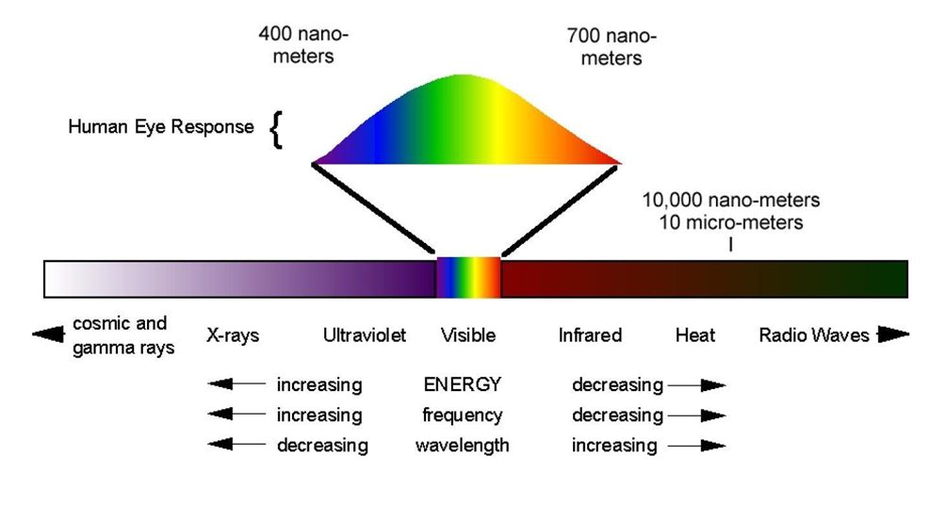

**Fig1.:Visible Light Spectrum**

**Lighten the darkness**

To turn a light into a Li-Fi router involves modulating its output, to carry a message, and linking it with a network cable to a modem that is connected to a telephone or cable-broadband service, just like a Wi-Fi router. Incandescent light bulbs and fluorescent tubes are not really

suitable for modulation, but they are yesterday’s lighting technology.

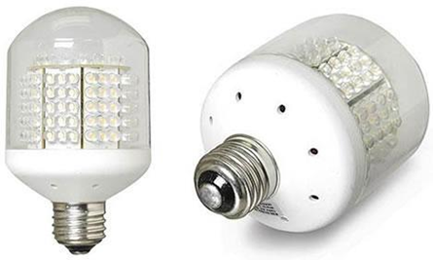

**Fig1.1:LED Light**

LEDs are rapidly replacing bulbs and tubes because they are more efficient. And because

they are semiconductor devices, tinkering with their electronics to produce the flickering signals

required for data transmission is pretty straightforward, according to Gordon Povey, who is

working on light communication with Harald Haas and his colleagues at the University of

Edinburgh, in Britain.

## Motivation

The underwater world is vast and largely unexplored, holding immense scientific and ecological value. By developing efficient and reliable wireless communication systems, we can enhance our ability to explore and understand the underwater environment. This motivation is driven by the desire to uncover new knowledge, discover marine life, study geological formations, and gain insights the Earth’s ecosystem.

Underwater robotics has become increasingly important in various industries, including offshore operations, marine research, and underwater infrastructure maintenance. Wireless communication is essential for controlling and gathering data from underwater robotic systems. Developing robust communication techniques can improve the capabilities of underwater robots, enabling them to perform complex tasks more effectively and autonomously.

The health and well-being of our oceans are critical for sustaining life on Earth. Underwater wireless communication enables the deployment of sensor networks for real-time environmental monitoring, including factors such as water quality, temperature, and marine biodiversity. Such monitoring is crucial for detecting environmental changes, managing natural resources, and implementing effective conservation measures.

Offshore industries, such as oil and gas exploration, require communication solutions that can operate reliably in underwater environments. Underwater wireless communication facilitates real-time monitoring of underwater structures, pipelines, and equipment, ensuring safe and efficient operations. By improving communication capabilities, we can enhance safety measures, prevent accidents, and optimize resource utilization.

Developing effective underwater wireless communication systems requires overcoming technical challenges and pushing the boundaries of existing technologies. This project aims to foster innovation by exploring novel approaches, such as acoustic, optical, and electromagnetic communication, and by addressing challenges related to data rates, energy efficiency, and signal processing. Advancements in underwater wireless communication can have broader implications, spurring technological progress in related fields.

As the demand for resources and scientific exploration expands, so does the need for sustainable practices. Underwater wireless communication can contribute to sustainable development by reducing the need for physical connections, minimizing human intervention, and optimizing energy consumption. This project seeks to explore energy-efficient designs, underwater wireless power transfer, and the integration of renewable energy sources for prolonged underwater communication capabilities.

## Objectives and Scope

The objective of underwater wireless communication is to enable reliable and efficient transmission of data for underwater exploration, robotics, environmental monitoring, and offshore operations.

Develop robust communication techniques to facilitate exploration and understanding of the underwater environment. Enhance the capabilities of underwater robotics systems through reliable wireless communication for improved control and data gathering. Enable real-time environmental monitoring and conservation efforts through the deployment of underwater sensor networks.

Ensure safety and efficiency in offshore operations by enabling real-time monitoring of underwater infrastructure .Foster technological advancements and innovation in underwater communication technologies. Contribute to sustainable practices by optimizing energy consumption and exploring renewable energy integration for prolonged underwater communication capabilities.

1. Marine research and exploration: Underwater wireless communication enables data collection, exploration, and research in the vast and unexplored underwater realm.
2. Offshore oil and gas operations: It facilitates remote control, monitoring, and maintenance of underwater infrastructure, ensuring safe and efficient offshore operations.
3. Environmental monitoring and conservation: Wireless communication enables real-time monitoring of water quality, temperature, and marine biodiversity, aiding in environmental conservation efforts.
4. Underwater robotics and autonomous vehicles: Reliable communication supports underwater robotic systems for tasks such as exploration, inspection, and search and rescue missions.
5. Underwater infrastructure maintenance and monitoring: Communication systems allow for remote monitoring and maintenance of underwater structures, pipelines, and equipment.
6. Scientific data collection and analysis: Underwater wireless communication facilitates the collection and analysis of scientific data, contributing to our understanding of marine ecosystems and geological formations.

The goals of an underwater wireless communication project are to develop reliable, efficient, and advanced communication systems underwater. Develop reliable and efficient communication protocols for underwater environments.

Improve data transmission rates and bandwidth capacity. Mitigate propagation delays and environmental effects. Enhance power efficiency and energy harvesting capabilities. Enable seamless integration with underwater robotics and sensor networks. Foster advancements in underwater communication technologies for diverse applications.

* 1. **Applications:**
* Marine research and exploration.
* Offshore industries (e.g., oil and gas operations).
* Environmental monitoring and conservation.
* Underwater robotics and autonomous vehicles.
* Underwater infrastructure maintenance and monitoring.

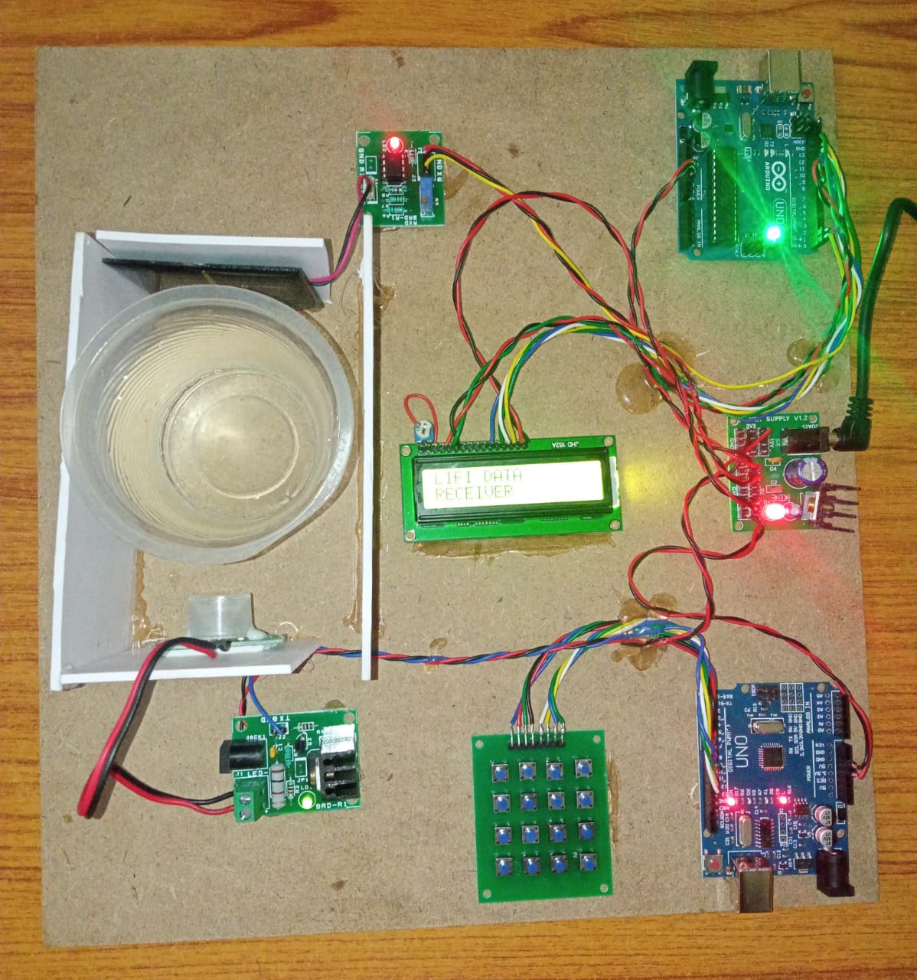

**Fig1.2.:Underwater Wireless Communication Model**

# CHAPTER 2

**LITERATURE SURVEY**

**2.1** **"Underwater acoustic communication channels: Propagation models and statistical characterization,":A Survey by** **M. Stojanovic(2005)**

This paper provides an overview of underwater acoustic communication channels, including propagation models and statistical characterization. It discusses the challenges and opportunities for underwater wireless communication.

**2.2** **"Underwater acoustic sensor networks: Research challenges," A Survey by F. Akyildiz, D. Pompili, and T. Melodia(2009)**

This paper presents an in-depth survey of research challenges in underwater acoustic sensor networks (UASNs). It discusses various aspects, including network architecture, MAC protocols, localization, and data routing in UASNs.

**2.3"A survey of routing protocols for underwater wireless sensor networks," A Survey by N. Y. Foo and A. A. Mamun(2012)**

This survey paper focuses on routing protocols for underwater wireless sensor networks. It provides an overview of different routing protocols, categorizes them based on their characteristics, and discusses their advantages and limitations.

**2.4 "Underwater wireless sensor networks: Applications, advances, and challenges,"A Survey by K. Dey, S. Das, and A. R. Roy(2013)**

This paper focuses on underwater wireless sensor networks (UWSNs) and discusses various applications, advances, and challenges in the field. It covers topics such as network architecture, routing protocols, and energy management in UWSNs.

**2.5 "Routing protocols in underwater wireless sensor networks: A survey," Subjected by X. Cheng, J. Li, and S. K. Das(2014)**

This survey paper explores routing protocols specifically designed for underwater wireless sensor networks. It provides a comprehensive overview of various routing protocols and compares their performance based on different metrics.

# CHAPTER 3

# BLOCK DIAGRAM

# 4x4 Keypad

8

9

10

11 **Arduino Tx Uno**

**Board**

4

5

6

7

VCC 5V GND

**LiFi**

**Transmitter**

**Tx**

R1

R2

R3

R4

C1

C2

C3

C4

**Power LED**

# fr

# From power

# Supply module

# Fig3.1.:Block diagram of Transmitter

**LCD 16x2**

rs en d4 d5 d6 d7

VCC GND

**Photo diode**

**(Solar Panel)**

8

9

**Arduino**  10

**Uno** 11

**Board**

12

13

VCC

Rx GND

# 

**Receiver module**

**VCC Gnd** Rx

# From power supply

# module

# From power

# supply module

# Fig3.2.:Block diagram of Receiver

# BLOCK DIAGRAM DESCRIPTION

# Transmitter (Data Interface, Encoder, Modulator) - LED Transmitter - Underwater Environment - LED Receiver - Demodulator - Decoder (Data Interface) - Receiver. Data is encoded, modulated, transmitted via LED, received by LED sensor, demodulated, decoded, and finally received by the receiver underwater.

# METHODOLOGY

# Sending messages

There are two main senses of the word "message" in computer science: messages passed within software, which may or may not be human-readable, and human- readable messages delivered via computer software for person-to-person communication.

• [Message passing is](http://en.wikipedia.org/wiki/Message_passing) a form of communication used in concurrent and parallel computing, object-oriented programming, and inter-process communication, where communication is made by sending messages to recipients. In a related use of this sense of a message, in [object-oriented programming languages s](http://en.wikipedia.org/wiki/Object-oriented_programming_language)uch as [Smalltalk or](http://en.wikipedia.org/wiki/Smalltalk) [Java,](http://en.wikipedia.org/wiki/Java_(programming_language)) a *message* is sent to an [object, sp](http://en.wikipedia.org/wiki/Object_(computer_science))ecifying a *request* for action.

• [Instant messaging a](http://en.wikipedia.org/wiki/Instant_messaging)nd [e-mail a](http://en.wikipedia.org/wiki/E-mail)re examples of computer software designed for delivering human-readable messages in formatted or unformatted text, from one person to another.

Steps for sending a message:

1. First a connection is established wherein the transmitter is connected to the computer using USB to TTL adaptor.

2. Similarly the receiver is switched on the and plugged to the other computer.

3. Respective port setting are done in the ‘Devices Manager’.

4. Now we run the program and an window appears where again the ports need to be configured.

# 

# 

5. Once this is done we are ready to send a message.

6. A message is typed in a particular field which is as shown**.**

# 

7. If the connections are done properly then we will receive the same message on the other device.

# 

**Sending files**

This programme will also be used to send image as well as doc files.

The image and doc files are first converted into its binary form and it sent bit by bit through the visible light LED. The detector detects the change in the intensity of the LED and thus reconstructs the original file at the receiver.

Steps for sending a file:

1. First a connection is established wherein the transmitter is connected to the computer using USB to TTL adaptor.

2. Similarly the receiver is switched on the and plugged to the other computer.

3. Respective port setting are done in the ‘Devices Manager’.

4. Now we run the program and an window appears where again the ports need to be configured.

# 

# 5. Once this is done we are ready to send a doc/image file.

# 

6. The doc/image file is loaded using the ‘send file’ option.

7. If the connections are done properly then we will receive the same doc/image file on the other device.

# 

# 3.3.:FLOWCHART

Transmitter

Data

Interface

Data

Encoder

Encoded

Modulator

Modulated

LED

Transmitter

Light

Underwater

Environment

Light

LED Receiver

Detected

Demodulator

Demodulated

Decoder

Data

Data Interface

Receiver

**Fig3.3:Flowchart of underwater wireless communication**

1. Transmitter: The device that transmits the data to be communicated underwater.
2. Data Interface: Interface that connects to the data source and provides the data to the encoder.
3. Encoder: Converts the data into a suitable format for transmission.
4. Modulator: Modulates the encoded data onto a carrier signal for transmission.
5. LED Transmitter: The LED used as a light source to transmit the modulated signal.
6. Underwater Environment: Represents the medium through which the light signal propagates.
7. LED Receiver: The LED used as a light sensor to receive the modulated light signal.
8. Demodulator: Extracts the modulated data from the received light signal.
9. Decoder: Converts the demodulated data back into its original format.
10. Data Interface: Interface that connects to the data receiver and provides the decoded data.
11. Receiver: The device that receives the transmitted data.

# CHAPTER 4

**HARDWARE**

**4.1 Circuit Diagram**

**Transmitter:**

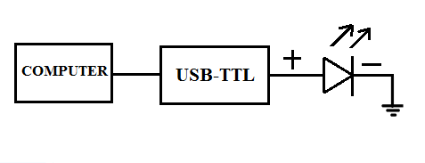

**Figure 4.1: Circuit Diagram Of Transmitter**

**Receiver:**

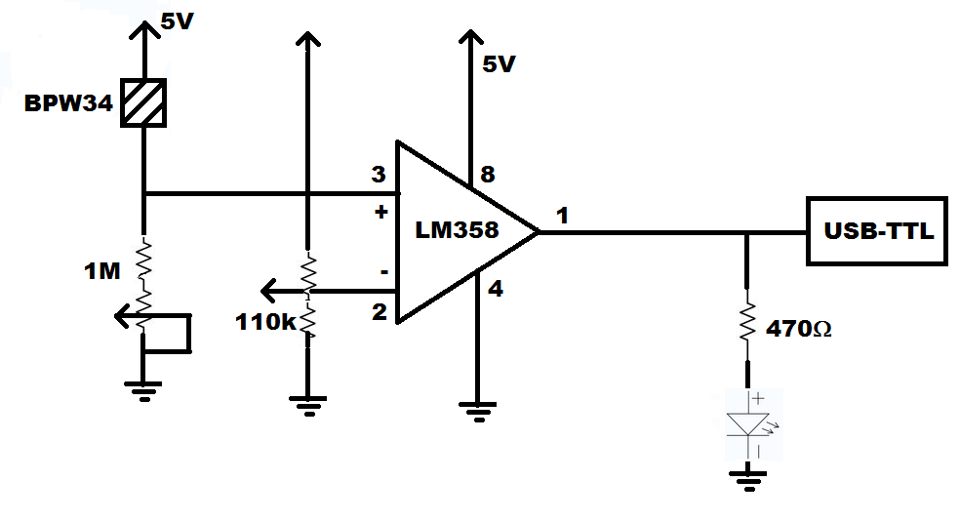

**Figure 4.2: Circuit Diagram Of Receiver**

**4.2 Hardware Requirements**

**1. IC LM358**

**DESCRIPTION:**

The LM358 is a great, easy-to-use dual-channel [op-amp.](http://wiki.bildr.org/index.php/Opamp) Op-amps have so many applications we figured we should probably carry at least one in a [DIP package.](http://wiki.bildr.org/index.php/DIP) LM358 applications include [transducer amplifiers,](http://wiki.bildr.org/index.php?title=Transducer_amplifiers&amp;action=edit&amp;redlink=1) DC gain blocks and all the conventional op-amp circuits. If you're looking for a good, standard op-amp the LM358 should fill most of your needs. It can handle a supply of 3-32VDC and source up to 20mA per channel. This op-amp is great if you need to operate two individual op-amps from a single power supply. It comes in an 8-pin DIP package.

**Features:**

• Two internally compensated op-amps

• Internally frequency compensated for unity gain

• Large DC voltage gain: 100 dB

• Wide bandwidth (unity gain): 1 MHz (temperature compensated)

• Wide power supply range:

• Single supply: 3V to 32V

• or dual supplies: ±1.5V to ±16V

**Pin diagram:**

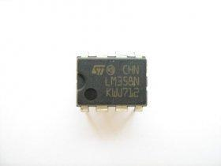

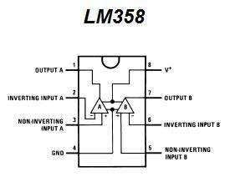

**Figure 4.3: Pin Diagram Of LM358**

**2. PIN photodiode BPW34**

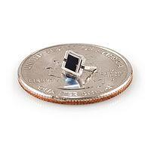 **Figure 4.4: Pin Photodiode BPW34**

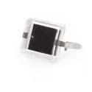

The BPW34 is a tiny, general purpose [PIN photodiode. This](http://wiki.bildr.org/index.php?title=PIN_diode&amp;action=edit&amp;redlink=1) [photodiode h](http://wiki.bildr.org/index.php/Photodiode)as a ton of uses, one of which is to use it is a mini [solar cell to](http://wiki.bildr.org/index.php/Solar_cell) power your project. The cell is sensitive to a wide range of light [wavelengths (](http://wiki.bildr.org/index.php?title=Wavelengths&amp;action=edit&amp;redlink=1)430-1100nm), so it should produce power in a number of different settings. The rated open circuit voltage is 350mV

(900nm, 1mW/cm2 light source), and short circuit current is 47μA.

If you shine a 940nm [infrared LED on](http://wiki.bildr.org/index.php/Infrared) one of them it will produce about 0.5VDC open circuit voltage. Stringing four together in series, we were able to turn an LED on with them. They'll also produce a small voltage, ~250mV, in a brightly, fluorescent-lit room.

**Features:**

• Package type: leaded

• Package form: top view

• Radiant sensitive area (in mm2): 7.5

• High photo sensitivity

• High radiant sensitivity

• Suitable for visible and near infrared radiation

• Fast response times

• Angle of half sensitivity: ϕ = ± 65°

**3. Power supply**

• **Circuit Diagram**

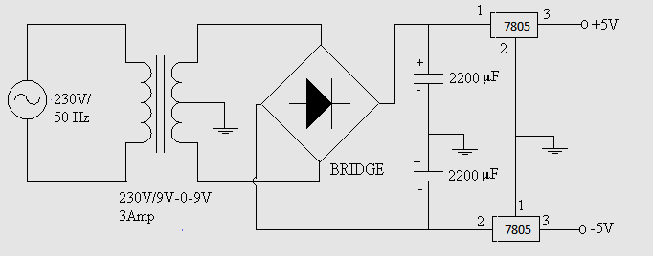

**Figure 4.5: Circuit Diagram Of Power Supply**

The essential components of the power supply are:

• **TRANSFORMER:**

As name suggests it transforms the voltage level from one level to another. Transformer used is the step down transformer to step 230 v to +5v.It provides isolation too from the mains.

• **RECTIFIER:**

The rectifier is used to convert A.C to D.C voltage. The design that we have carried out is of the full wave rectifier, using 1N4001 diodes are use.

The bridge rectifier has advantage over the full wave rectifier like:

▪ The need for the centre-tapped transformer is eliminated.

▪ The PIV is one half of the centre–tap circuit.

• **FILTER:**

A filter circuit is a device, which removes ac component of rectified output but allows the dc component to reach the load. The filter used is a simple capacitor of 100µf /25v.

• **REGULATOR:**

A voltage regulator is a circuit that supplies a constant voltage regardless of changes in load current The regulator used in our project is IC7805, which is a three terminal voltage regulator. A heat sink is used, so that the heat produced by the regulator dissipating power has a larger area from which to radiate the heat into the air by holding the case temperature to a much lower value than would result without the heat sink.

• **PCB Layout**

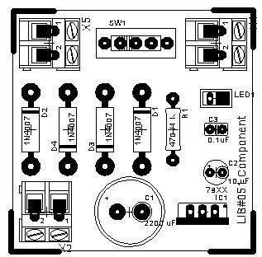

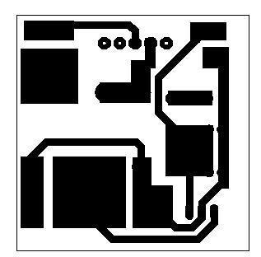

**Figure 4.6: PCB Layout**

**4. LED**

▪ **Description :**

A **light-emitting diode** (**LED**) is a semiconductor light source. LEDs are used as indicator lamps in many devices and are increasingly used for other [lighting.](http://en.wikipedia.org/wiki/Lighting) Appearing as practical electronic components in 1962, early LEDs emitted low- intensity red light, but modern versions are available across the [visible,](http://en.wikipedia.org/wiki/Visible_spectrum) [ultraviolet,](http://en.wikipedia.org/wiki/Ultraviolet) a[nd infrared wavelengths,](http://en.wikipedia.org/wiki/Infrared) with very high brightness.

When a light-emitting [diode is](http://en.wikipedia.org/wiki/Semiconductor_diode) forward-[biased (](http://en.wikipedia.org/wiki/Voltage_bias)switched on), electrons are able to [recombine with](http://en.wikipedia.org/wiki/Carrier_generation_and_recombination) [electron holes with](http://en.wikipedia.org/wiki/Electron_hole)in the device, releasing energy in the form of [photons.](http://en.wikipedia.org/wiki/Photon) This effect is called [electroluminescence a](http://en.wikipedia.org/wiki/Electroluminescence)nd the [color of](http://en.wikipedia.org/wiki/Color) the light (corresponding to the energy of the photon) is determined by the [energy gap of](http://en.wikipedia.org/wiki/Energy_gap) the semiconductor. An LED is often small in area (less than 1 mm2), and integrated optical components may be used to shape its radiation pattern. LEDs present many [advantages o](http://en.wikipedia.org/wiki/Light-emitting_diode#Advantages)ver incandescent light sources including [lower energy consumption,](http://en.wikipedia.org/wiki/Energy_conservation) longer [lifetime, i](http://en.wikipedia.org/wiki/Service_life)mproved physical robustness, smaller size, and faster switching. LEDs powerful enough for room lighting are relatively expensive and require more precise current and [heat management than](http://en.wikipedia.org/wiki/Thermal_management_of_high-power_LEDs) compact [fluorescent lamp sour](http://en.wikipedia.org/wiki/Fluorescent_lamp)ces of comparable output.

▪ **Physics :**

The LED consists of a chip of semiconducting material [doped with](http://en.wikipedia.org/wiki/Doping_(semiconductor)) impurities to create a [p-n junction.](http://en.wikipedia.org/wiki/P-n_junction) As in other diodes, current flows easily from the p-side, or [anode, to](http://en.wikipedia.org/wiki/Anode) the n-side, or [cathode, but](http://en.wikipedia.org/wiki/Cathode) not in the reverse direction. Charge-

carriers — [electrons a](http://en.wikipedia.org/wiki/Electron)nd [holes —](http://en.wikipedia.org/wiki/Electron_hole) flow into the junction from [electrodes with](http://en.wikipedia.org/wiki/Electrode)

different voltages. When an electron meets a hole, it falls into a lower [energy level,](http://en.wikipedia.org/wiki/Energy_level) and releases [energy in](http://en.wikipedia.org/wiki/Energy) the form of a photon.

[The wavelength of](http://en.wikipedia.org/wiki/Wavelength) the light emitted, and thus its color depends on the [band gap e](http://en.wikipedia.org/wiki/Band_gap)nergy of the materials forming the p-n junction. In [silicon](http://en.wikipedia.org/wiki/Silicon) or [germanium](http://en.wikipedia.org/wiki/Germanium)diodes, the electrons and holes recombine by a non-radiative transition, which produces no optical emission, because these [are indirect band gap mat](http://en.wikipedia.org/wiki/Indirect_band_gap)erials. The materials used for the LED have a [direct band gap with](http://en.wikipedia.org/wiki/Direct_band_gap) energies corresponding to near-infrared, visible, or near-ultraviolet light.

**5. Pre-set Resistors**

• Pre-set resistors are used in circuits when it is necessary to alter the resistance.

Dark/light and temperature sensors usually have these components as the pre- set resistor allows the circuit to be made more or less sensitive (they can be turned up or down - reducing or increasing resistance).

• A small screwdriver can be used to turn the centre part of the pre-set resistor, altering the value of the resistance.

The range of resistance varies, for example:

0 to 100 ohms

0 to 1M ohms

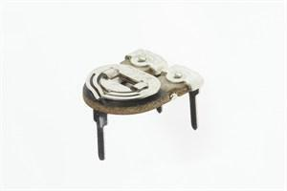

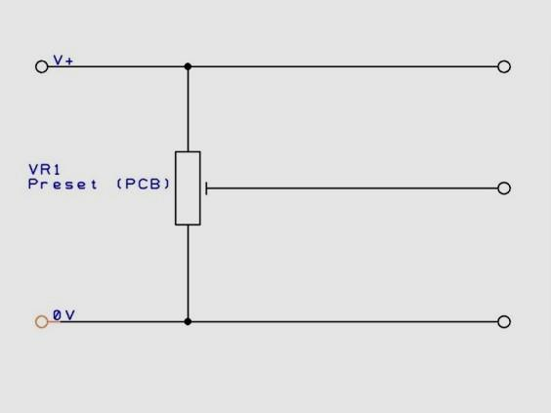

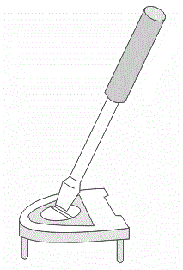

**Figure 4.7: Pre-set Resistors**

**6. USB to TTL Adapter: CP2102**

**Description:**

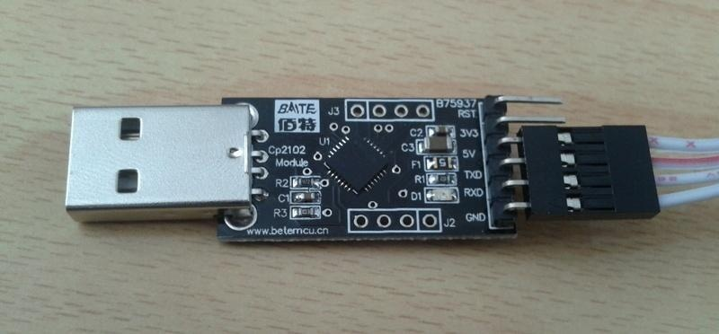The CP2102 is a highly-integrated USB-to-UART Bridge Controller providing a simple solution for updating RS-232 designs to USB using a minimum of components and PCB space. The CP2102 includes a USB 2.0 full-speed function controller, USB transceiver, oscillator, EEPROM, and asynchronous serial data bus (UART) with full modem control signals in a compact 5 x 5 mm QFN-28 package. No other external USB components are required.

**Figure 4.8: USB to TTL Adapter: CP2102**

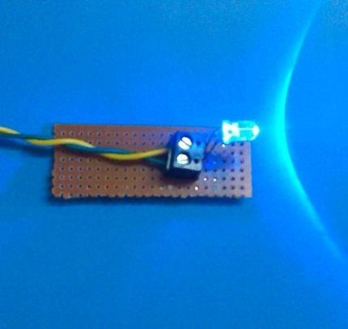

**Figure 4.9: Transmitter Real view**

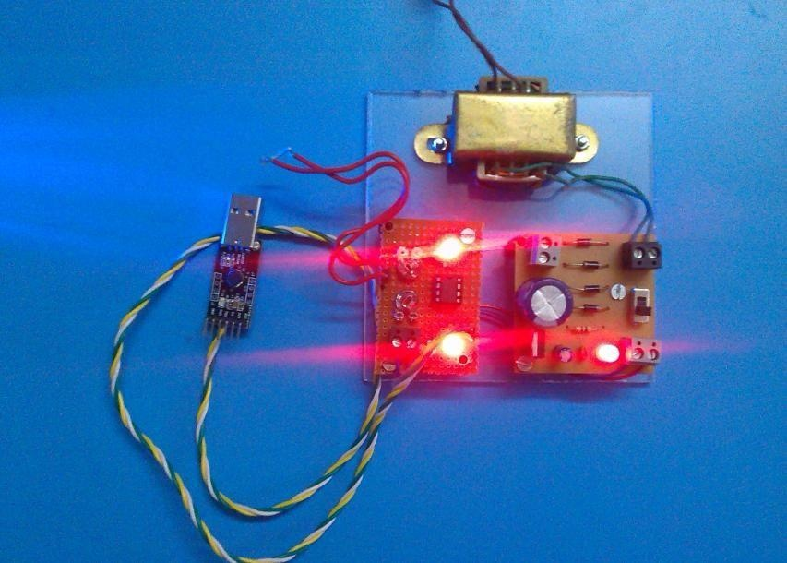

**Figure 4.10: Receiver Real view**

**5 Software Requirement**

**VISUAL BASICS 6.0**



**Description:**

What Is Visual Basic?

Programmers have undergone a major change in many years of programming various machines. For example what could be created in minutes with Visual Basic could take days in other languages such: as "C" or "Pascal". Visual Basic provides many interesting sets of tools to aid you in building exciting applications. Visual Basic provides these tools to make your life far easier because all the real hard code is already written.

With controls like these you can create many applications which use certain parts of windows. For example, one of the controls could be a button, which we have demonstrated in the "Hello World" program below. First create the control on the screen, then write the code which would be executed once the control button is pressed. With this sort of operation in mind, simple programs would take very little code. Why do it like the poor old "C" programmer who would have to write code to even display a window on the screen, when Visual Basic already has this part written for you.

Even though people tend to say Visual Basic's compiler is far behind the compilers of Pascal and C, it has earned itself the status of a professional programming language, and has almost freed BASIC of the reputation of a children's language. Overall you would class Visual Basic as a Graphics User Interface (GUI). Because as you draw, you write for the program. This must always be remembered in any kind of creation of a Visual Basic program. All in all, VB is the preferred language of many future programmers.

With VB 6, you can create any program depending on your objective. For example, if you are a college or university lecturer, you can create educational programs to teach business, economics, engineering, computer science, accountancy, financial management, information system and more to make teaching more effective and interesting. If you are in business, you can also create business programs such as inventory management system, point-of-sale system, payroll system, financial program as well as accounting program to help manage your business and increase productivity. For those of you who like games and working as games programmer, you can create those programs as well. Indeed, there is no limit to what program you can create! There are many such programs in this tutorial, so you must spend more time on the tutorial in order to learn how to create those programs.

# CHAPTER 6

**ADVANTAGES AND APPLICATION**

**6.1 Features**

▪ It is a new source of data transmission (i.e.) VISIBLE LED LIGHTS.

▪ Bandwidth is not limited.

▪ It can produce data rates faster than 10 megabits per second, which is speedier than your average broadband connection.

▪ Transmitters and receivers devices are cheap, and there is no need for expensive RF units.

▪ As light waves do not penetrated opaque objects, they cannot be eavesdropped.

It is very difficult for an intruder to (covertly) pick up the signal from outside the room. i.e. .There can be no theft of data.

▪ Visible light radiations are undoubtedly free of any health concerns. Therefore, these systems will receive acceptance for use in hospitals, private homes, etc. Furthermore, no interference with RF based systems exists, so that the use in airplanes is uncritical.

▪ Visible LEDs can offer very high brightness, very low power consumptions and long lifetime. They can serve two purposes at the same time: lighting and high speed wireless data transmission.

▪ The visible spectrum covers wave lengths from 380 nm to 750 nm.

▪ Visible light communication could be used in conjunction with Power line communication (PLC).

▪ VLC is a natural broadcast medium; it is sometimes desired to send information back to the transmitter.

▪ Taking the fiber out of fiber optics by sending data through an LED light bulb that varies in intensity faster than the human eye can follow.

▪ VLC can be used as a communications medium for ubiquitous computing, because light-producing devices (such as indoor/outdoor lamps, TVs, traffic signs, commercial displays, car headlights/taillights) are used everywhere.

**6.2 Applications**

Many prospective applications have been suggested. These include:

▪ This technology could be used in conjunction with Power-line Communication (PLC). The idea is that voltage changes in an electrical wire, which serves as PLC carrier, are reflected by the flickering of a light source. In that way, PLC data can be forwarded using this technology.

▪ Items at exhibitions or museums could be fitted with a li-fi transmitter which sends information about itself to nearby receivers.

e.g. a scenario where a museum visitor might be provided with auditory information about the item he is currently standing in front of.

▪ Another field of application for this project lies in vehicle to vehicle communication.

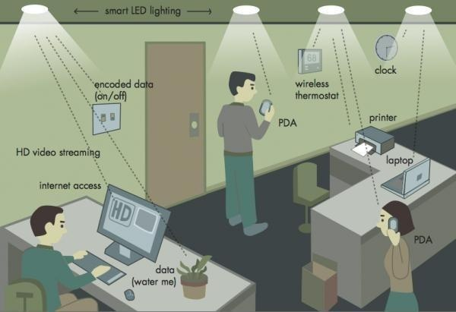

▪ Communications medium for computing.

▪ Alternative to Wi-Fi.

● Can also be used for traffic analysis and accident control.

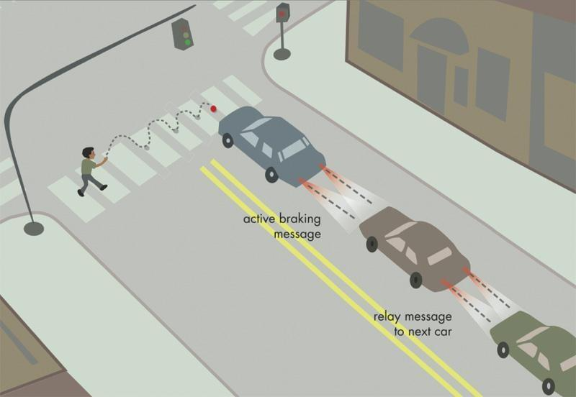

▪Since the explosion of ubiquitous devices such as smart phones, tablet computers, smart household appliances and the increasing demand for having wireless high quality media access, data traffic with very high data rates are required to prevent the scarce radio spectrum resource from being overwhelmed.

▪Visible lighting is fundamentally much better suited than radio for achieving very high data rate densities. On top of this, visible light can much better be directed and isolated, enabling multiple independent high capacity links, making the technology very suitable for ad hoc networking.

**Ad hoc networking**

▪One of the most promising applications is in car-to-car communication. If the headlights on a car could communicate with the tail lights of the car ahead, VLC collision-avoidance technology would be hugely significant in the automotive industry.

▪In the same way, traffic lights could send detailed information of congestion up ahead directly to a vehicle.

▪This way of transferring data represents a significant step towards realizing a vision of a low-cost, energy-neutral, bulb replacement that can provide ubiquitous wireless network access for any application requiring lighting.

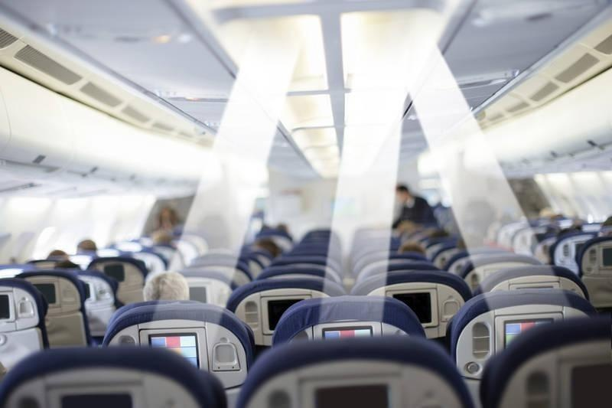▪Also visible light communication is very suitable for use in hospitals and aircrafts since it doesn’t interfere with radio-frequency electronics and it has no associated health concerns.

▪The possibility of using existing infrastructure, instead of investing in and installing new connections, makes the technology environmentally friendly and allows for future expansion of the network.

▪ **SMART LIGHTING**

Smart buildings require smart lighting. Smart lighting with VLC provides the infrastructure for illumination, control and communications and will greatly reduce wiring and energy consumption within a building.

▪ **MOBILE CONNECTIVITY**

By pointing a visible light at another device you can create a very high speed data link with inherent security. This overcomes the problems of having to pair or connect and provides a much higher data rate than Bluetooth or Wi-Fi.

▪ **DEFENCE & SECURITY**

The ability to send data quickly and in a secure way is the key to many applications. The fact that the visible light cannot be detected on the other side of a wall had great security advantages.

▪ **UNDERWATER COMMUNICATIONS**

RF does not work underwater but visible light can support high speed data transmission over short distances in this environment. This could enable divers and underwater vehicles to talk to each other.

▪ **LOCATION BASED SERVICES**

Each visible light information source can be uniquely identified, so the location of any VLC device can be identified quickly and accurately.

# RESULT

The results of underwater wireless communication using LED technology have shown significant advancements in enabling reliable and efficient data transmission in underwater environments. This approach has addressed some of the key challenges faced in underwater communication, such as signal attenuation and multipath propagation.

LED-based underwater wireless communication systems have demonstrated several advantages. LEDs, being compact and low-power devices, are well-suited for underwater applications. They offer high-speed modulation capabilities, enabling the transmission of data at higher rates. Additionally, LEDs can operate in a wide range of wavelengths, allowing for flexibility in system design and compatibility with different underwater conditions.

The use of LEDs as both transmitters and receivers has yielded positive results. LEDs as light sources provide a focused and directional beam, enhancing signal transmission efficiency. LEDs as light sensors exhibit high sensitivity to detect the received light signal accurately.

Researchers and engineers have employed various signal processing techniques to improve the performance of underwater wireless communication systems. Adaptive modulation techniques dynamically adjust the modulation scheme based on the prevailing channel conditions, optimizing the data rate and reliability. Error correction coding schemes are implemented to mitigate the effects of noise, interference, and signal distortion, thereby improving the overall communication reliability.

While underwater wireless communication using LEDs has shown promising results, challenges remain. The range of communication is limited due to the attenuation of light in water. Additionally, multipath propagation and underwater obstacles can introduce signal reflections and distortions, affecting the signal quality.

Overall, the results of underwater wireless communication using LED technology indicate significant progress in achieving reliable data transmission in underwater environments. Continued research and development in signal processing, adaptive techniques, and system design will contribute to further improvements in data rates, range, and overall performance of underwater communication systems.



**Fig: Prototype of the model**

# CONCLUSION

It has been shown that even though most existing efforts are still in a very early stage, VLC is a promising technology with a wide held of prospective applications. An ever- growing interest in VLC throughout the world can be expected to lead to real-world applications in the future. In some fields of application it poses a favourable alternative to conventional solutions (infrared, WLAN etc.).The transmission is based on the assumptions of direct LOS (line-of-sight) channels and simplex channel conditions. The encoding and decoding is used in the transmitter part and receiver part to reduce the error in transmission.

In addition, the data transmission rate could be enhanced by using fast switching multiple LEDs. The driving speed of the circuit could also be enhanced if fast switching transistors were used. It was demonstrated that the blue LED based visible light data transmission system is indeed technically feasible. The tests were carried out under moderate indoor ambient light conditions. It is envisaged larger coverage can be obtained by using LED arrays. Finally, the wireless communication technology could be embedded into the visible light source which is the ultimate goal of the project.

**FUTURE MODIFICATION**

D-Light, can produce data rates faster than 10 megabits per second, which is speedier than your average broadband connection. We expect a future where data for laptops, smart phones, and tablets is transmitted through the light in a room. And security would be a snap if you can’t see the light, you can’t access the data.

You can imagine all kinds of uses for this technology, from public internet access through street lamps to auto-piloted cars that communicate through their headlights. And more data coming through the visible spectrum could help alleviate concerns that the electromagnetic waves that come with Wi-Fi could adversely affect your health.

There are around 14 billion light bulbs worldwide, they just need to be replaced with LED ones that transmit data. VLC is a factor of ten cheaper than Wi-Fi Because it uses light rather than radio-frequency signals, VLC could be used safely in aircraft, integrated into medical devices and hospitals where Wi-Fi is banned, or even underwater, where Wi-Fi doesn't work at all.

**REFERENCES**

1. M. Stojanovic, "Underwater acoustic communication channels: Propagation models and statistical characterization," IEEE Communications Magazine, vol. 47, no. 1, pp. 84-89, January 2009.
2. K. Dey, S. Das, and A. R. Roy, "Underwater wireless sensor networks: Applications, advances, and challenges," International Journal of Distributed Sensor Networks, vol. 9, no. 4, article ID 735396, 2013.
3. F Akyildiz, D. Pompili, and T. Melodia, "Underwater acoustic sensor networks: Research challenges," Ad Hoc Networks, vol. 3, no. 3, pp. 257-279, May 2005.
4. N. Y. Foo and A. A. Mamun, "A survey of routing protocols for underwater wireless sensor networks," Sensors, vol. 12, no. 2, pp. 1327-1357, January 2012
5. X. Cheng, J. Li, and S. K. Das, "Routing protocols in underwater wireless sensor networks: A survey," IEEE Communications Surveys & Tutorials, vol. 16, no. 4, pp. 1978-1998, Fourth Quarter 2014.